VistaVu & EdEx

Project Validation Report

Contract Rule Extraction

Jun 10, 2025

CONTENTS
EXECUTIVE SUMMARY 4
PROBLEM DEFINITION 5
DATA UNDERSTANDING 7
ML RECOMMENDATIONS 10
High Level Solution 10
Data Preparation 11
Document Metadata Extraction 12
Document Loading and Preparation 12
Document Splitting 13
Rule Classification 14
Annotation or Labeling 14
Post-Output Processing and Rule Management 14
Choosing an LLM 14
Key Dimensions 14
Evaluating LLM Options 15
General Purpose vs. Domain-Specific LLMs 15
Open Source vs. Closed Source LLMs 15
Hybrid Approaches 16
Techniques for Maximizing LLM Performance 17
Prompt Engineering 17
Best Practices for Prompt Engineering 17
Controlling Inference Parameters 18
Advanced Prompting Strategies 18
Fine Tuning 19
When To Fine Tune 20
Parameter-Efficient Fine-Tuning (PEFT) 20
Best Practices for Fine-Tuning 21
Model Evaluation 21
NEXT STEPS & OPPORTUNITIES WITH AMII 22
APPENDIX 23
APPENDIX A: ML PROJECT ROADMAP 23
APPENDIX B: AI ETHICS AND RESPONSIBLE USE 25

DISCLAIMER

This report is presented by the Alberta Machine Intelligence Institute (Amii) to VistaVu. The purpose of this report is to scope out the defined business problem in the context of machine learning (ML) and suggest approaches which can help VistaVu to lay the groundwork required to prepare in the process of adopting ML for their business. This report is a result of research and multiple discussions between Amii and VistaVu. Amii makes no warranties or guarantees as to the returns or effort required to execute on these opportunities. This report is intended only as a suggested recommendation of potential approaches. These recommendations may be re-evaluated by Amii team members as part of future engagements and may shift based on new and updated information available at that time. Any machine learning services to be provided to VistaVu are subject to VistaVu and Amii’s executed services agreement.

EXECUTIVE SUMMARY
We are pleased to present VistaVu with a Project Validation Report on the application of artificial intelligence (AI) and machine learning (ML) methods for contract rule extraction.
Over the course of approximately six weeks, Amii took a business problem that VistaVu identified -- contract rule extraction -- and investigated different ways to approach the problem in the context of ML.
Amii reviewed the literature around the domain of the problem and existing ML approaches potentially related to the identified business problem. Amii also dedicated time to understand existing businesses working in a similar problem space, as well as specific factors relevant to this application of ML by VistaVu. This report summarizes the findings from the literature survey of related existing work, both from a domain perspective and ML perspective, and suggests potential ML strategies to address the defined problem.
Going forward, there is some necessary groundwork required prior to adopting ML approaches to address the given problem:
- Document Collation: The contractual documents that the LLM should parse to extract the rules should be gathered in a location easily accessible to the LLM.
- Metadata Extraction: In order to apply the rules extracted by an LLM to transactional documents, metadata that determines whether the rule is applicable to the given document must be available. The relevant metadata fields should be enumerated and populated for at least some of the contractual documents prior to testing the LLM.
- Evaluation Process: VistaVu and Edmonton Exchanger should either prepare a small evaluation set, or be prepared to assess the LLM output to aid in generating one once the first models come online.
Completing this preparatory work prior to the project kickoff will ensure that the resident is set up to develop the LLM portion of the pipeline. Amii will continue to work with VistaVu to guide this data preparation, and as they take their next steps in developing the rule extraction pipeline.

PROBLEM DEFINITION
VistaVu is a technology company specializing in providing business management solutions, including ERP systems and data analytics, to field service companies. VistaVu is partnering with Edmonton Exchanger (EdEx), one of their valued clients, to build a platform that addresses significant operational challenges through the application of advanced technologies. This collaboration aims to leverage VistaVu's technological expertise to solve specific, complex problems faced by EdEx in their daily operations.
Edmonton Exchanger (EdEx) is a company providing field services to customers in the oil and gas industry, including heat exchanger maintenance and repair, pressure vessel components, pipe and custom fabrication. These services involve deploying crews to customer sites, tracking labor, materials, and equipment usage, and subsequently billing customers based on this activity.
EdEx faces significant challenges in its billing, payment, and reconciliation processes, stemming primarily from discrepancies between EdEx's internal records and customer systems. Customers typically pay based on their own data and records, not directly from EdEx's submitted invoices. This necessitates a complex and time-consuming manual effort by EdEx staff to ensure their invoice submissions align with customer expectations and data formats, or to quickly identify and rectify customer errors to prevent transaction rejections. Key pain points include:
- Manual Data Entry and Inconsistency: Time and activity data are initially captured manually on crew sheets before being entered into internal systems (FieldVu, SAP Business One). This manual process is prone to inconsistencies and requires significant effort from timekeepers for correction and verification against policies and agreements.
- Discrepancy Identification and Resolution: Differences in billing rates, work dates, hours, reference numbers (work order, project, timesheet), and coding (labor) between EdEx's data and customer systems lead to transaction rejections. Investigating and resolving these discrepancies is a manual, time-consuming process, often lacking clear explanations from the customer.
- Payment Application and Reconciliation: Matching customer payments (remittances) to EdEx's invoices is challenging because customers pay based on approved transactions, not necessarily tied to specific invoice lines or even the original work order/project. This manual matching process is complex, especially with high transaction volumes, and can lead to misapplied payments and errors.
- Reliance on Expertise and Lack of Codified Rules: The current processes rely heavily on the expertise of experienced staff who understand site-specific rules, union agreements, customer contracts, and historical payment patterns. Many of these rules are not formally documented, residing instead in "cheat sheets" or the knowledge of key personnel, making training difficult and processes inconsistent, particularly during busy periods with temporary staff.
- Financial Risk: Delays in identifying and resolving discrepancies, especially for work completed months prior, increase the risk of uncollectible revenue and write-offs. The current manual methods are time-consuming (estimated at several hours per day per site for balancing, plus additional time for payroll and reconciliation), limiting the ability to proactively address issues.
Through their work with EdEx, VistaVu seeks to streamline and automate the accounts receivable (AR) billing, payment application, and reconciliation processes to reduce manual effort, minimize financial write-offs, improve cash flow, and enhance the accuracy and timeliness of financial reporting. A key objective is to automate the identification of discrepancies between EdEx and customer data at various stages (pre-submission, post-submission, payment reconciliation) and to improve the efficiency of applying customer payments to the correct invoices. One component of this that can be addressed through machine learning is the construction of a pipeline for processing contractual documents and verifying that these are being consistently applied to timesheets and purchase orders.
This problem can be framed as a combination of tasks:
- Information Extraction (NLP): Extracting relevant rules, and terms (e.g., overtime rules, meal allowances, markup percentages, effective dates) from unstructured or semi-structured documents like collective agreements, and customer contracts. The input would be text documents (PDF, Word, Excel), and the output would be structured data representing the extracted rules and their validity periods.
- Discrepancy Detection / Anomaly Detection: Identifying potential errors or inconsistencies in timesheet and billing data by comparing it against extracted rules and historical patterns. This would involve developing custom software that takes EdEx timesheet/billing data, extracted rules, and customer data as input and outputs flagged transactions, potentially listing a reason for the discrepancy.
The high volume of transactions, the variability of rules across different customers and projects, the dynamic nature of these rules (rate changes, contract amendments), and the need to process both structured and unstructured data make this a suitable problem for machine learning, which can learn complex patterns and adapt to variations more effectively than rigid rule-based systems.

DATA UNDERSTANDING
The data for this project originates from several internal systems and external sources used by EdEx and its customers. The primary data sources can be broadly categorized into transactional data and document data.
- Transactional Data: This category includes data generated from daily operations related to field work, invoicing, and payments.
  - Field Tickets/Crew Sheets: Data is initially captured manually on paper field tickets, which are then entered daily as crew sheets into the FieldVu system. These crew sheets capture details such as customer, project, date, workers, hours worked, work performed, and expenses. Each time or expense item is recorded as an individual crew sheet line.
  - AR Invoices: Based on unbilled crew sheets, AR invoices are generated, typically weekly. This data is exported from FieldVu to EdEx’s payroll system and SAP ERP system for customer billing. AR invoices capture all Field Ticket data for a specific customer, project, and week, including billing codes, quantities, rates, amounts, and references to source Field Tickets. Invoices typically contain a few dozen lines each, with a high volume of invoices generated for any given engagement.
  - Customer System Data: AR invoices are submitted into the Customer's system. The Customer system also provides full data dumps of all paid and unpaid transactions.
  - Payment Remittance Advice: Customers send details of payments separately, usually 60-90 days after invoicing, on a Payment Remittance Advice. These remittances are hundreds of transaction lines long and include details like Customer Timesheet ID and payment amounts. Remittances are received one at a time, and a comprehensive report of payments is not available.
  - Other Transactional Data: This includes IOL Terminal charges (emailed, not uploaded), Track files (customer's record of work), and Remittance files. Records of modifications made to timesheets before submission or during payroll processing are also relevant.
- Document Data: This category includes policy documents, agreements, contracts, and internal reference materials.
  - Policy and Agreement Documents: These include various Collective Agreements (e.g., Alberta National Maintenance Agreement, Boilermaker Collective Agreement, Union Collective Agreements for Saskatchewan Unions), Alberta Employment Standards, Customer Event Specific Agreements, Customer Contracts + Amendments, and Customer Contract Rate Amendments. Public documents such as employment standards can be found on the internet, while contractual documents are saved on EdEx's SharePoint.
  - Cheat Sheets: These are documents produced by EdEx as a quick reference guide to some of the most commonly used components of contractual documents, including rates, meal break and allowances, and rules for overtime/double time. There are cheat sheets for equipment, invoices in contract, and labor. These are also stored on EdEx's SharePoint.
  - Internal Documents: Other documents such as Sub-Contractor agreements, Tallies, and lists of employees are stored on SharePoint.
Transactional data primarily resides in structured systems like FieldVu and SAP, but is also exchanged and processed using spreadsheets (e.g., Excel pivot tables, tallies) and manual methods. Data dumps from customer systems are also available. The structure is typically tabular, with individual lines representing time or expense items (crew sheets), billing items (AR invoices), or payment transactions (remittance advice).
Document data is largely unstructured text within various file formats (PDFs or similar) stored in organized folder structures on SharePoint, often categorized by customer. Some metadata for documents, such as validity status (VALID, EXPIRED), worksite, client, and keywords, is available or can be added.
There are high volumes of data, from Crew Sheets to AR Invoices to Payment Remittances, and some sites involving hundreds of employees. Remittances can reach 10 per day during peak periods (turnaround), representing thousands of transactions totaling millions of dollars in revenue. Document quantities are estimated between 30-50 to potentially 100 documents, including multiple documents within agreements. Historical data for payments from the customer system is available yearly, but a comprehensive report of payments is not, and the timeframe for investigating problems is typically looking back six months. The data is highly granular, captured at the level of individual Field Ticket lines (time/expense items), AR Invoice lines (billing items), and Payment Remittance lines (payment transactions).
Data quality is a significant challenge, with common discrepancies between EdEx’s submissions and customer records leading to transaction rejections for various reasons like incorrect rates or unapproved transactions. The payment determination and application process is largely manual, increasing the potential for human error, such as payments being applied to incorrect A/R invoices. Inconsistency exists among timekeepers, and master data setup can cause issues if incorrect. Customer system changes after invoicing and payment are hard to track, and manual processes require specific skills (Excel, pivot tables) which not all staff possess. Audits are on-demand and manual. Errors are estimated at 2-5%, which can accumulate into significant amounts. There are gaps in data completeness; customer rejections often lack explanations, and records of modifications made to timesheets before submission are not consistently kept.
A comprehensive report of payments received is not available, as remittances come in one at a time. Reasons for discrepancies are often free text from manual markups and may not be systematically captured. Dates of validity for documents are not always obvious. Current tools offer limited automation, requiring significant manual effort for reconciliation, which is time-consuming and prone to error. Customer-specific reference numbers add complexity, and customers have varying approval processes and timing. If discrepancies are found too late, that revenue may not be recoverable. Customer system changes are difficult to track, and codified rules for referencing and reconciliation are not written down, relying on individual expertise. Access issues exist for some data sources (e.g., UKG, details of what happens to manual sheets), and agreements can be redacted or outdated with lots of revisions lacking remarks.
As a final note, it should be noted that while VistaVu is partnering with EdEx to develop the initial MVP, the production version will aim to address the similar problems for multiple clients. For this reason, it is likely that in the course of developing the initial solution VistaVu may leverage documents for other clients.

ML RECOMMENDATIONS
Amii has developed a framework for ML project execution, as seen in Figure 1. Through this project validation, we are progressing through the Business Understanding & Problem Discovery stage of the Machine Learning Process Lifecycle (MLPL), and planning the ML development process accordingly.
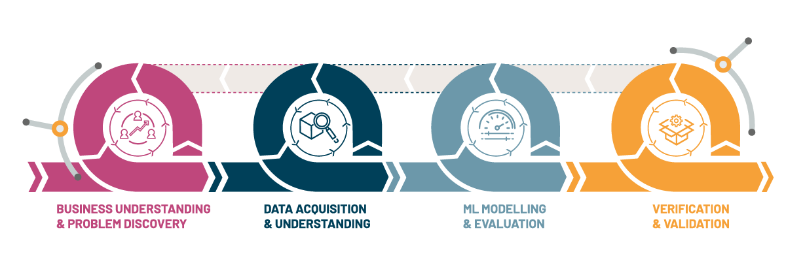Figure 1. The Machine Learning Process Lifecycle.
The second stage of the MLPL, Data Acquisition and Understanding (DAU), serves as a prerequisite to the development of any ML solution. Before ML development is possible, the data needs to be available in an easily consumable format. For VistaVu/EdEx this primarily entails organizing contractual documents in an accessible location with the necessary metadata to assess whether the document is relevant to a particular line item. This, together with the necessary formatting steps for applying an LLM, are outlined in the Data Preparation section. Best practice guidelines for for choosing and adapting an LLM to perform the rule extraction are then outlined in the Choosing an LLM and Techniques for Maximizing LLM Performance sections.

High Level Solution
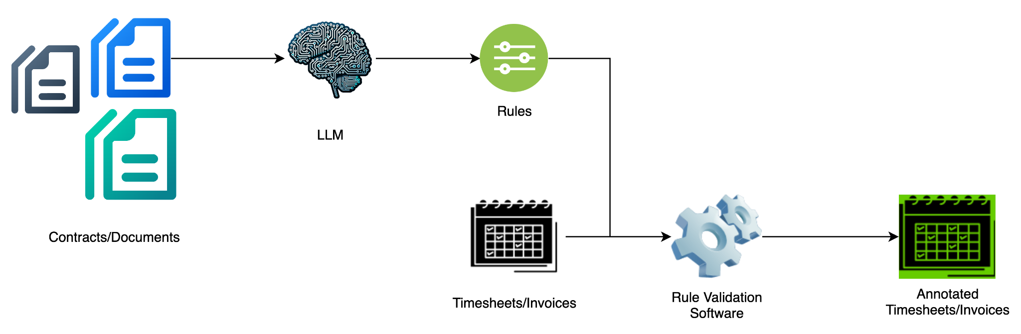
Figure 2. The rule extraction pipeline.
An overview of the proposed rule extraction pipeline is illustrated in Figure 2. The contractual documents are first parsed by an LLM to extract rules in two formats: a machine readable logical representation, and a human readable description. Figure 3 illustrates the two formats for the extracted rules.
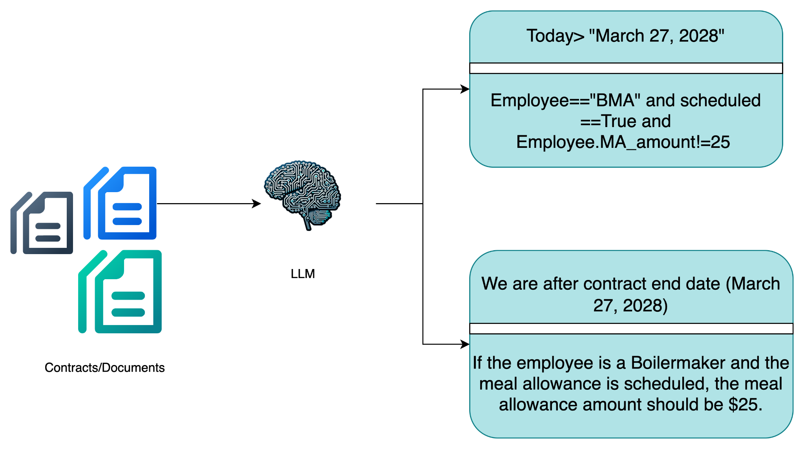
Figure 3. An example of the machine and human readable The Machine Learning Process Lifecycle.
Once extracted, these rules are uploaded to a database as a single record, together with metadata describing the source document, validity period, worksite, client, and any other information required to determine the rule’s applicability to crew sheets/invoices. This rules database will serve as a knowledge repository to be referenced when validating transactional data. Once rules are extracted, the LLM will only need to be called when new documents are uploaded, including amendments/revisions to existing contracts. Where amendments trigger an end date for existing rules, the database update will need to add this end date to the existing rules’ metadata, as well as update the document supescedence.
The rule validation software then processes the crew sheets/invoices, determining which rules are relevant to the line items in the document, checking that they have been adhered to, and highlighting instances where they have not. While the rule validation software could leverage machine learning, a more reliable solution can be achieved with traditional software, so long as there are only limited variations in transactional document formats to be processed.
When designing the interface for the rule validation software it is important to allow for timekeepers to flag incorrectly extracted rules. These can then be corrected in the rules database, ensuring that future transactional software is correctly validated.

Data Preparation
The data preparation process involves several steps to transform raw data from various sources into a format suitable for rule extraction using Large Language Models. This includes metadata extraction, document loading, and the preparation of a validation set. An essential component of the solution will also include setting up a pipeline for storing and updating the extracted rules. Each of these components will be outlined in the following subsections.

Document Metadata Extraction
Document metadata is information assigned to a document to provide additional context and structure. This metadata is crucial for understanding the applicability of extracted rules and information. Document-level metadata is needed so that it can be inherited by the rules extracted from that document. Key metadata fields required to determine if an extracted rule applies to an individual crew sheet include:
- Client: Rules are often specific to a client's contract. Matching the client on the crew sheet to the client metadata of the rule is essential.
- Worksite: Rules may vary based on the worksite or location. Matching the worksite on the crew sheet to the worksite metadata of the rule ensures correct application.
- Validity Period: Documents and the rules extracted from them have a validity period. Rules from expired documents (metadata indicating EXPIRED status) are not applicable to current crew sheets, likewise past crew sheets will need to be assessed relative to the documents in effect at the time.
- Employee Relevance: Metadata can flag which specific employees or groups of employees a rule is relevant for, allowing for precise application based on the individuals listed on the crew sheet.
- Contract/Document Linkage: Establishing which contract or document a rule originated from is fundamental. This linkage allows the system to pull the correct set of rules based on the contract associated with the crew sheet.
- Contract/Document Supercedence: Over time contracts are revised and amended, leading to instances where clauses in one document may override those in another. The document priority required to resolve these conflicts should be captured in the metadata.
This metadata should be stored alongside the documents and linked to the extracted rules when they are stored in the database. LLM responses during the extraction process can also be tagged with this metadata.
This metadata can be prepared in a variety of ways. The simplest is manual extraction, where a domain expert enumerates the relevant metadata for a document. For some fields, it is also likely that LLMs can also be leveraged to help automate the metadata extraction. Where this is the case, the extracted fields should still be verified by a domain expert prior to upload into the document database. Document metadata can then be inherited by the extracted rules when the rules database is populated.

Document Loading and Preparation
Input documents are received in various formats including PDF, Excel, and Word. These documents must be loaded and processed to extract their content, typically text, into a format suitable for input into the Large Language Model for extraction and annotation tasks. Libraries such as LangChain have document loaders for more than 80 document formats and should be considered in this preparation step.

Document Splitting
Given the potential length of documents like agreements and contracts, which can exceed the context window limitations of some Large Language Models, techniques such as document splitting and chunking may be valuable. This involves breaking down the document content into smaller, manageable segments or chunks. Each chunk can then be processed individually or in sequence by the language model, allowing the model to handle large documents effectively for rule extraction.
A chunk should contain information that is semantically related and contextually meaningful. Determining the optimal way to chunk the data requires experimentation, specialized knowledge, and consideration of constraints such as context window limits.
This process might seem straightforward, but the way splits occur can greatly influence subsequent tasks. Consider an example involving a detailed description of a smartphone and its features. If we split this information carelessly, different parts of the description may end up in separate chunks, hindering our ability to answer questions correctly.
For instance:
- Chunk 1: "The new smartphone model features a cutting-edge display with a resolution of"
- Chunk 2: "1080x2400 pixels and a battery life of up to"
- Question: "What is the display resolution of the new smartphone?"
In this case, the necessary information about the smartphone's features might not be available in either chunk, making it difficult to provide a complete answer.
Many text splitters operate by dividing text into chunks of a certain size, often allowing for a slight overlap between consecutive chunks. This overlap ensures that the same context appears at the end of one chunk and the beginning of the next, fostering a sense of continuity.
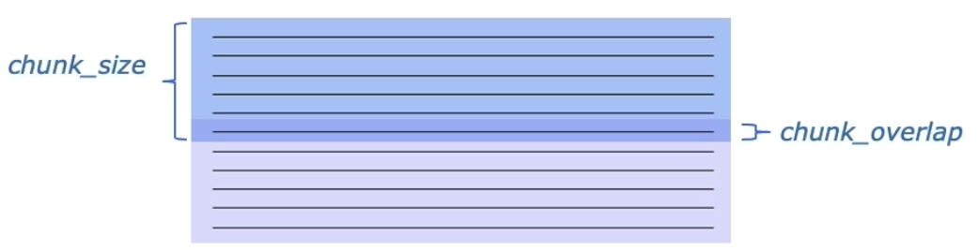Figure 4: Splitting Text with Chunk_overlap (Taken from LangChain documentation)
The size of the chunks can be measured in various ways. Some splitters use characters, others use tokens, and some even utilize smaller models to recognize the end of a sentence, paragraph or section, using that as a way of splitting chunks.

Rule Classification
To assist the Large Language Model in extracting specific rules from documents, a well-structured list of the kinds of rules to be extracted can be included in the LLM prompt. Examples of extracted rules could include OT/DT Rules, OT Meal Rate, LOA/Travel Guidelines, and information regarding chargeability (Equipment, Third Party, Training, Markup).

Annotation or Labeling
A critical step involves establishing ground truth for model evaluation. This ground truth, representing "what is correct and what is incorrect," may be stored in a spreadsheet, or database. Human evaluation will play an important role in improving the extracted rules and labels. The comparison to the ground truth for extracted rules can be achieved in one of two ways:
- Checking extracted rules against a ground truth set of rules for the document.
- Applying the extracted rules to crew sheets which are known to be correct/incorrect and assessing which discrepancies are correctly or incorrectly identified.
In the first case, the ground truth rules do not need to reflect all documents in the EdEx system, but can be chosen from a representative subset. They can also be prepared iteratively, with the LLM performing initial extraction, a human expert evaluating and correcting the rules, and the corrected set of rules being saved as ground truth examples for the refinement of future versions of the LLM.

Post-Output Processing and Rule Management
The primary output of the Large Language Model for document extraction tasks is a set of rules derived from the input documents. These extracted rules need to be processed and managed for subsequent use in automated systems. The output rules should be available in specific formats: a machine-readable logical rule suitable for direct application in automated processes, and a plain text description for human review, understanding, and validation. These output rules should be stored and managed within a database.
The process of populating this database involves extracting the rules, linking them to relevant metadata (like document validity, worksite, client, and employee relevance). Updates to the rule database will occur as new documents are processed, existing documents are revised, or as human evaluation leads to refinements of the extracted rules. This database serves as the central repository for the extracted knowledge, enabling its application in various downstream tasks such as validating timesheets or automating identification and matching processes.

Choosing an LLM
An essential component of constructing a rule extraction system for VistaVu.

Key Dimensions
Selecting the appropriate LLM for your specific use case involves considering and balancing several factors. Here are key dimensions to consider:
- Accuracy and Capability: Determine the accuracy and capability requirements of your project. If high accuracy is paramount, you may opt for state-of-the-art models even if it means sharing data with third parties.
- Data Security: Consider data security requirements, especially whether your data can be shared with external entities or needs to be hosted locally or within specific geographical boundaries.
- Cost: Assess the cost implications, which include the expenses associated with using APIs or hosting the model.
- Performance and Latency: Evaluate the performance needs, particularly the speed and latency of the model, which are critical for real-time applications.
For contract rule extraction, data security is likely to be the most critical dimension, followed by accuracy. This prioritization will guide the selection of the most suitable LLM.

Evaluating LLM Options
With the critical dimensions of accuracy and data security in mind, we can evaluate the following LLM options:

General Purpose vs. Domain-Specific LLMs
- General Purpose LLMs: These models are trained on a wide variety of data, making them versatile and capable of performing well across multiple tasks. Examples include OpenAI’s GPT and Google’s Gemini.
- Domain-Specific LLMs: These models are optimized for specialized fields such as customer service, finance, medicine, or chemistry. An example in the legal domain is LegalBERT, which is trained specifically on contractual documents. While an LLM trained specifically on the domain of interest sounds like a promising choice, newer versions of general-purpose LLMs can sometimes outperform older domain-specific LLMs. Thus, a comparative evaluation is recommended.

Open Source vs. Closed Source LLMs
- Closed Source LLMs: These models, such as OpenAI’s GPT and Google’s Gemini, are usually state-of-the-art and are often easier to integrate into your applications via APIs. However, they provide less flexibility and control compared to open-source models, which could conflict with data security requirements.
- Open Source LLMs: These models, like the LLaMA and Mistral families, offer greater control and customization and can be self-hosted, providing higher data security. However, they are usually not as powerful as closed-source models, at least before fine-tuning. Using open-source models often necessitates careful consideration of the model size due to its impact on accuracy, cost, and latency.
Table 1 presents a comparative analysis of various open and closed-source LLMs, focusing on the following factors: model size (where applicable), licensing options, Arena Elo Rating (adapted from chess, with higher scores indicating better performance), associated costs in USD, and the maximum token input size each model can handle.
Choosing between open-source and closed-source LLMs involves weighing the benefits of control and customization against capabilities, ease of integration, and ongoing management.

Hybrid Approaches
For complex tasks, it can be beneficial to employ multiple LLMs, leveraging a more powerful model for sophisticated steps and simpler, cost-effective models for straightforward tasks, though for the purpose of rule extraction it is likely that a single model will suffice.
Tools like Hugging Face’s chatbot arena and other comparative platforms can assist in evaluating and selecting LLM for your needs.
Table 1: Comparative analysis of various open and closed-source LLMs
 | LLaMA 3 |  | Mixtral-8x7b | Gemini 1.5 Pro | Claude |  | GPT-4o
 | 8B | 70B | Mixtral-8x7b | Gemini 1.5 Pro | 3 Opus | 3.5 Sonnet | GPT-4o
Size | 8 billion | 70 billion | 46.7 billion | ? | ? | ? | ?
Licenses | Llama 3 Community | Llama 3 Community | Apache 2.0 | Proprietary | Proprietary | Proprietary | Proprietary
Arena Elo Rating | 1153 | 1207 | 1114 | 1265 | 1249 | 1272 | 1287
Costs in USD | Ml.g5.2xlarge 1.2$ per hour on demand | Ml.g5.48xlarge  16$ per hour on demand | Ml.g5.48xlarge  16.28$ per hour on demand | Input:$0.0035 / 1K token  Output:$0.0105 / 1K tokens  (Approximately) | Input:$0.015 / 1K token  Output:$0.075 / 1K tokens | Input:$0.003 / 1K token  Output:$0.015 / 1K tokens | Input: $0.005 / 1K tokens  Output:$0.015 / 1K tokens
Max token input size | 8k | 8k | 32k | 1M | 200K | 200K | 128k

Techniques for Maximizing LLM Performance
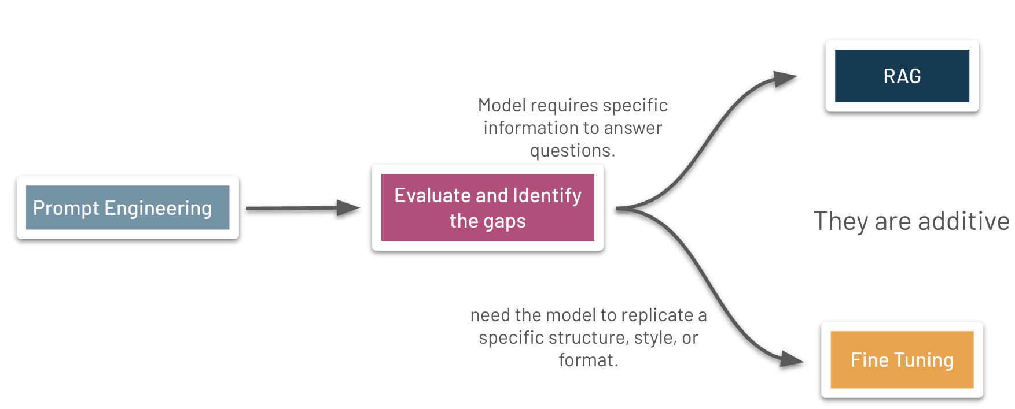
Figure 5: Techniques for Maximizing LLM Performance (Credit: OpenAI)
The three most common techniques for maximizing LLM performance are prompt engineering, Retrieval Augmented Generation (RAG), and fine-tuning, as shown in Figure 5 above. Amii recommends following prompt engineering best practices and utilizing advanced prompting techniques as outlined below to guide the LLM. If prompt engineering has been thoroughly explored and the desired performance is still not satisfactory, fine-tuning a pre-trained LLM using LoRA can be a viable solution to address the issue.
A RAG system could also be incorporated if additional information that should be dynamically added to the model context exists. This would only be useful if such information can’t be added to the model context, and is less likely to add value for the system being deployed by VistaVu.

Prompt Engineering
The input that is sent to an LLM is typically called a prompt. Prompt engineering is the practice of developing and optimizing the prompt to effectively use the LLM for a specific application. A well-designed prompt typically includes three elements:
- Instructions: Clearly define tasks, such as extracting rules in a specific format based on input data.
- Context: Provide necessary background and relevant information, such as previously extracted rules and information specific to the worksite.
- Input Data: The specific data to be processed, in this case, is the contractual document.

Best Practices for Prompt Engineering
Constructing an effective prompt is both an art and a science. The following best practices can help construct effective prompts:
- Be Clear and Specific: Ensure that prompts are straightforward and detailed, avoiding any ambiguity. If a prompt is confusing for a human, it will likely be confusing for the LLM as well.
- Specify Format and Size: If you want the LLM to output a particular format (e.g., JSON, bullet points) or size (e.g., one sentence, one paragraph, the top three compounds), clearly state that.
- Use Delimiters: Separate different parts of the prompt using delimiters to enhance clarity.
- Use Few-Shot Learning: To help the LLM produce better responses, include a few example prompt-completion pairs (shots) within the context. Start with zero-shot (no examples) for new LLMs. If the results are not satisfactory, move to one-shot and few-shot examples to improve performance.
- Define Uncertainty Handling: Specify what the model should do if it does not know the answer.

Controlling Inference Parameters
Controlling various inference parameters, such as maximum tokens, temperature, and sampling methods (top-K and top-P), can further refine the model's output and balance creativity and determinism. For this case, lower temperature values (e.g., 0.1-0.2) are recommended (making the output more deterministic and less creative) to minimize hallucinations.

Advanced Prompting Strategies

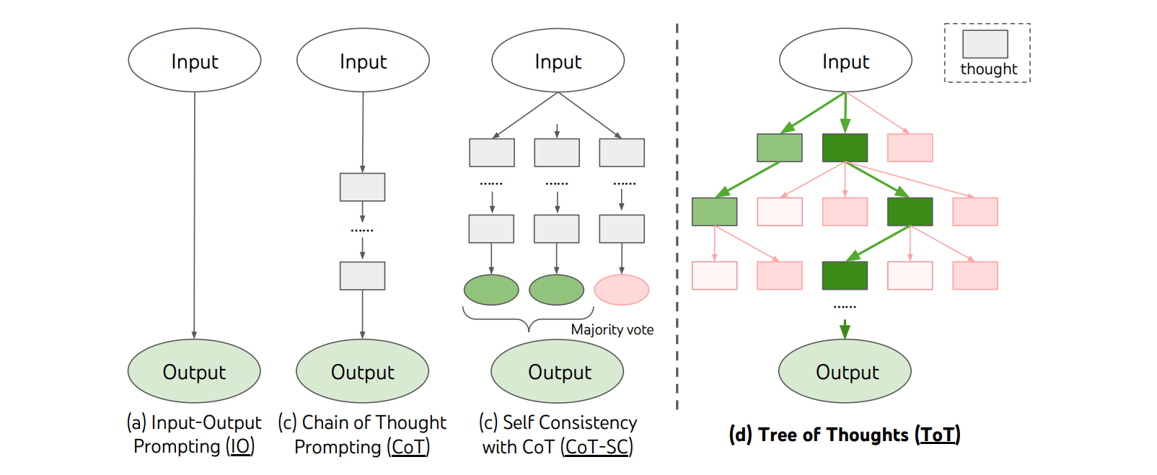
Figure 6: Advanced Prompting Strategies
For complex tasks, advanced prompting techniques will be needed to maximize the reasoning capability of the models. These include:
- Self-Critique Prompting: Self-Critique prompting is a technique that encourages the model to evaluate and refine its own responses. This method involves generating an initial response, and then prompting the model to critically analyze that response for potential flaws, biases, or areas of improvement. The model then produces a revised response based on this self-assessment. For rule extraction, self-critique could involve the model initially extracting a list of rules, then critically examining its own list for accuracy and completeness.
- Chain of Thought (CoT) Prompting: Chain of Thought prompting encourages the model to break down complex problems into step-by-step reasoning. This technique involves explicitly asking the model to "think through" a problem, showing its work and intermediate steps. By doing so, the model is more likely to arrive at accurate conclusions, especially for multi-step problems.
- Self-Consistency with CoT Prompting: Self-Consistency combines Chain of Thought prompting with multiple diverse solution attempts. This technique involves generating several independent reasoning paths for the same problem and then aggregating the results. By doing so, it helps mitigate potential errors or biases in a single chain of thought.
- Tree of Thoughts (ToT) Prompting: Tree of Thoughts prompting extends the concept of Chain of Thought by creating a tree-like structure of reasoning paths. This technique allows the model to explore multiple reasoning branches simultaneously, evaluating different possibilities at each step.
Figure 6 further illustrates the difference between these techniques.
- ReAct Prompting: ReAct (Reasoning and Acting) prompting combines language reasoning with decision-making and action steps. This technique allows the model to alternate between reasoning about a problem and taking actions, such as searching internal or external databases for relevant information. By doing so, the model can engage in a more dynamic and interactive analysis process, potentially uncovering insights that might be missed in a linear approach.
- Seek-and-Solve Prompting: Seek and Solve prompting divides the task of answering questions with a given table or text, into two steps. The first step involves locating relevant parts of information from the table only. Then in the second step, we prompt the LLM to use this relevant information to answer a question. This results in better accuracy at both individual tasks, as compared to singular prompts.
Amii recommends an iterative approach to implementing these advanced prompting techniques when developing the solution. Start by integrating CoT and Self-Critique prompting as the foundation. If CoT proves insufficient, consider incorporating Self-Consistency with CoT. Similarly, progress to ToT if the previous approaches fail to meet requirements. While each subsequent technique offers increased capabilities, they also introduce more complexity.

Fine Tuning
Fine-tuning adapts a pre-trained LLM to specific tasks by training it on additional data. This process enhances the model’s performance in domain-specific tasks. For VistaVu/EdEx, a natural pipeline of training samples for fine tuning can be captured by recording correction timekeepers make to extracted rules.

When To Fine Tune
Fine-tuning is beneficial when there is a need to customize the style, tone, or format of responses, improve reliability in producing the desired output, or embed complex instructions within the model. However, it is important to note that fine-tuning is not suitable for adding entirely new information to the model; for such tasks, RAG is more appropriate.
If prompt engineering is not consistently extracting rules in the expected logical format, or is missing legal nuance when interpreting contracts, fine tuning may be worth considering. It should be noted, however, that fine tuning a model is significantly more expensive than making adjustments through prompt engineering.

Parameter-Efficient Fine-Tuning (PEFT)
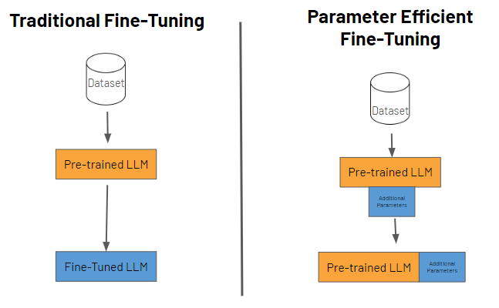
Figure 7: Traditional vs. Parameter Efficient Fine-Tuning
Traditional fine-tuning often requires a large amount of GPU RAM, significantly increasing the overall compute budget and cost. PEFT methods, such as Low-Rank Adaptation (LoRA), update a small set of new parameters, usually 1-2% of the original LLM weights. This makes the fine-tuning process faster, more memory-efficient, and cheaper. PEFT methods are also less prone to catastrophic forgetting because the weights of the original LLM remain frozen, preserving the model's original knowledge.
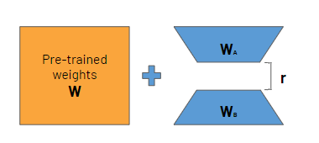
Figure 8: Combining pre-trained and fine-tuned weights.
LoRA is a commonly used PEFT technique that freezes the original weights of the LLM and creates new trainable low-rank matrices within the layers of the transformer architecture. The size of the low-rank matrices is set by a parameter called rank (r). A smaller value results in fewer parameters, making the model more memory-efficient, but it also reduces the capacity of the matrices to capture task-specific information.

Best Practices for Fine-Tuning
- Utilize Parameter Efficient Fine-Tuning: Use techniques such as LoRA instead of full fine-tuning.
- Quality over Quantity: Use high-quality, relevant data for fine-tuning
- Start Small: begin by fine-tuning the LLM on a subset of the dataset before scaling up. This approach helps identify potential issues early and saves resources.

Model Evaluation
Establishing robust evaluation methods is critical for comparing the performance of different models and ensuring they effectively address the rule extraction problem to reduce manual effort. For LLM-based tasks, evaluation can involve:
- LLM as a Judge: Utilizing another LLM to assess the quality of the generated output (e.g., extracted rules, matched items) based on key metrics such as Coherence (logical flow and understandability), Relevance (pertinence to the task), and Groundedness (support from the source data).
- Human Evaluation: Involving human experts to review and verify the model's outputs, which is particularly important for tasks requiring nuanced understanding or where the cost of errors is high. Human evaluation plays a crucial role in improving rules and model performance. In particular, if humans are engaged to validate rules extracted by an LLM, these verified rules can form a validation set to assess the performance of future iterations of the LLM.
- Self-Consistency & Ensemble Agreement: Running the same input through the model multiple times or using different models and checking for agreement in the outputs. High agreement on extracted rules or matches increases confidence, while disagreements flag uncertain extractions requiring further review.
- Rule Verification: Rather than check the rules themselves, an alternative approach would be to verify their application to a set of crew sheets and invoices that are known to be correct or incorrect. This would require the preparation of both a validation set of crew sheets, as well as the development of the software that processes the rules and applies them to highlight errors.

NEXT STEPS & OPPORTUNITIES WITH AMII
VistaVu has signed on for two residencies to work with Amii on developing solutions to ML problems, beginning with the rule extraction problem detailed in this report. As part of this process Amii will recruit, hire, train, and manage an ML Resident who will be dedicated full time (1.0 FTE) to the project. The Amii ML Resident will be supervised and mentored by an Amii ML Project Lead (typically a more experienced ML scientist) throughout the engagement, and Amii will provide the project management framework to ensure consistent progress. The Amii ML Resident will build and iterate upon a proof-of-concept AI/ML model that can be leveraged in the development of a production solution.
The next stage in this process will involve resident recruitment, which will be conducted with input from VistaVu. Simultaneously, discussions will continue between VistaVu and Amii on possible future projects for the resident to work on. In parallel, Amii will guide VistaVu and Edmonton Exchanger through the necessary data preparation to support the resident once onboarded.
If there is interest, Amii can also support the upskilling of current team members, improving AI literacy at VistaVu. Amii offers several training programs, including the Specialization for Using ML Algorithms for Real World Applications on Coursera, offered by Amii and the University of Alberta as a fast-paced, unsupervised, and asynchronous delivery. Amii also offers several foundational classes to train and upskill employees on ML and its application.

APPENDIX

APPENDIX A: ML PROJECT ROADMAP
ML projects are exploratory and iterative. It is important to understand the major milestones in order to ensure progression towards the end goal. There are 5 key stages to consider when looking to successfully plan, execute, and deliver:
- Business Understanding & Problem Discovery
- Project Scoping & High-Level Requirements
- Proof of Concept Development
- MVP Development & Deployment
- Solution Operationalization & Maintenance
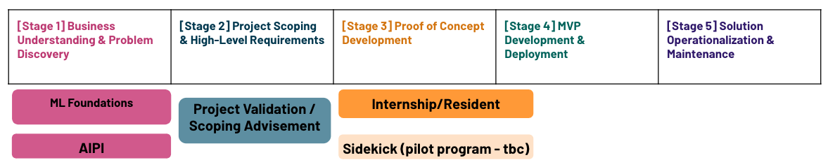
Figure 9. The stages of ML model development.
Factors within ML Projects are rarely the same making them difficult to plan upfront as new information is discovered at each stage. Often, requirements are elaborated throughout the project lifecycle. This can raise the need to repeat prior stages of a project to incorporate additional items identified. Because of this, a common challenge is to keep the project moving forward.
Following the Project Validation, Amii recommends beginning Stage 3 - Proof of Concept Development. Amii is happy to offer assistance in this stage. Please reach out to your Key Account Manager for further information.
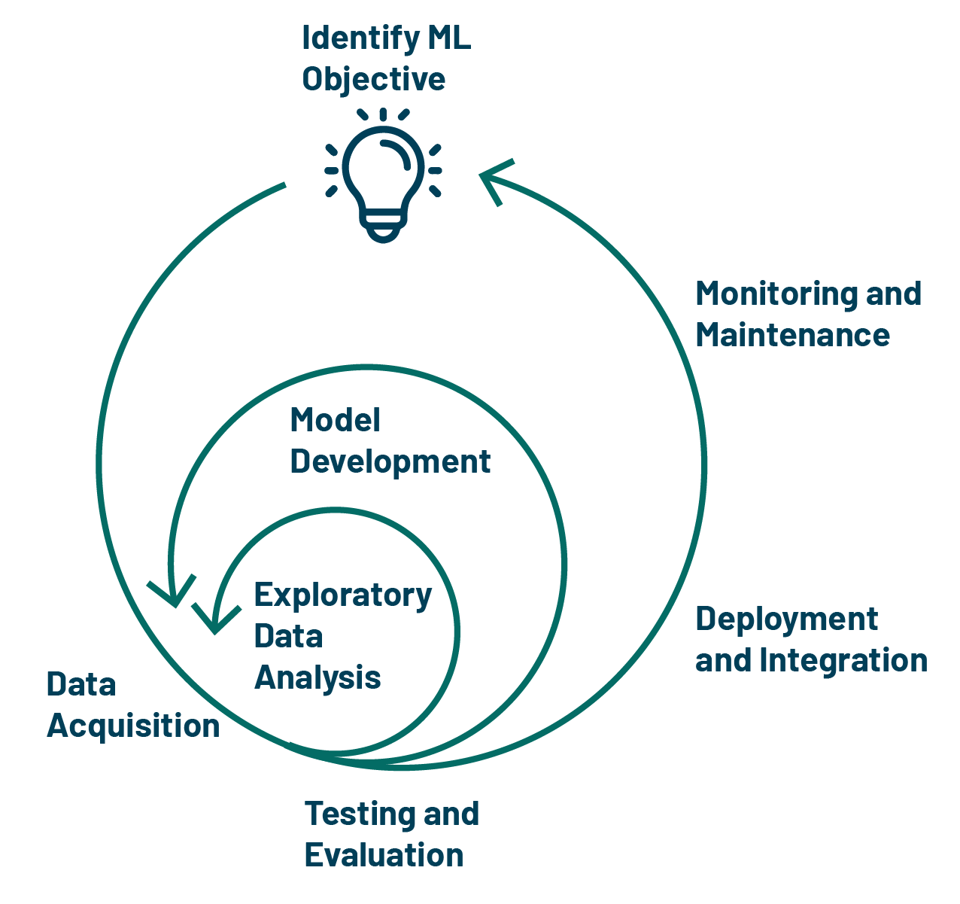
Figure 10. The iterative nature of ML model development.
The Figure above highlights another perspective on the project phases of AI/ML projects. AI/ML projects are highly exploratory and thus are best suited for an iterative and cyclical management approach. The various phases in the project life cycle provide checkpoints to reevaluate the project and make adjustments as needed. Due to the exploratory nature of projects, it is difficult to do end-to-end planning in detail. Therefore, it is recommended that the project phases be treated as project gates wherein a go/no-go decision is made based on information gathered throughout the phase. At the end of each phase, the project team should decide whether to proceed to further phases of the project, repeat a project phase, adjust project scope, or discontinue the project.

APPENDIX B: AI ETHICS AND RESPONSIBLE USE
Key ethical considerations include:
- Fairness and Non-Discrimination: Ensuring that the models do not perpetuate or exacerbate existing biases. Regularly audit and validate models to avoid discrimination based on race, gender, age, or any other protected characteristic.
- Transparency and Explainability: Where applicable, the decision-making process of the AI models should be transparent and understandable to stakeholders. Provide an explanation of how models arrive at their conclusions to maintain trust and accountability, recognizing that complete transparency may not always be required.
- Privacy and Data Security: Protect the privacy and integrity of data used in training and deploying models. Implement robust data governance practices and comply with relevant data protection regulations to safeguard personal and sensitive information.
- Accountability: Establishing clear accountability mechanisms for the outcomes produced by AI systems. This includes identifying responsible parties and having processes in place to address any negative impacts or errors caused by the models.
- Human-Centric Approach: Prioritizing human well-being and ensuring that AI systems augment human capabilities rather than replace them. Human oversight should be integrated into the AI deployment process to make critical decisions when needed.
By embedding these ethical principles into the AI development lifecycle, we foster trust and acceptance among users and stakeholders. Implementing AI ethically and responsibly is not just a technical challenge but a societal imperative, ensuring that the benefits of AI are distributed equitably and contribute positively to the broader community.
Suggested Reading:
- https://aws.amazon.com/blogs/machine-learning/learn-how-to-assess-risk-of-ai-systems/
- https://www.ibm.com/topics/responsible-ai
- https://www.unesco.org/en/artificial-intelligence/recommendation-ethics
- https://hbr.org/2020/10/a-practical-guide-to-building-ethical-ai

